Memories of a Scout Leader – Tales from the Past with Richard Biggs
Memory No. 1 – 3rd Streatham International Summer Camp to Andorra and Spain
So many scouts wanted to go on this camp that I had to hire two 15-seater mini buses. I drove one and Trevor James drove the other.
Our first problem was caused by French Customs who let Trevor through but demanded I fill in an itinerary detailing the daily mileage (or kilometrage) and all planned overnight stops as they classified my minibus as a coach. Perhaps they only counted 14 seats in Trevor’s minibus! I was also not allowed to drive at night.
The drive south through France went well after the customs issues there were no further problems until reaching the foothills of the Pyrenees as dusk approached.
I switched on the headlights of my minibus and the engine stopped. The alternator had not been charging the battery. Fortunately, Paul Tinwell was in the party so he swapped the batteries and we continued. I could not use headlights so followed Trevor’s minibus up the mountains and down into Andorra round a number of sharp hairpin bends. We wondered what the Andorra Border Guards made of the convoy but we made it up to the camp site in the dark, pitched our tents and settled in for a good night’s sleep.
Next morning, there was an irate framer complaining we had squashed his grass with our tents and demanded compensation.
I got the alternator repaired and we enjoyed sightseeing in Andorra for a while, but it appeared that a number of the party had always intended moving down to the Spanish Coast. Sun, sand and sangria was the attraction for some over the mountainous vistas, cool mountain streams and green valleys of Andorra. And so, it was to Estartit on the Costa Brava that our two mini buses headed when our time in Andorra was over.  It was at Estertit that the cheap Spanish drinks caused one scout to over indulge. His buddies duly moved him around the camp site so that I did not see the state he was in.  I can’t recall any other incidents and I can’t find any photo’s, which in the case of those that over indulged, is probably just as well.  Souvenirs from Estartit were purchased and can be seen to the right, and below. |  |  | 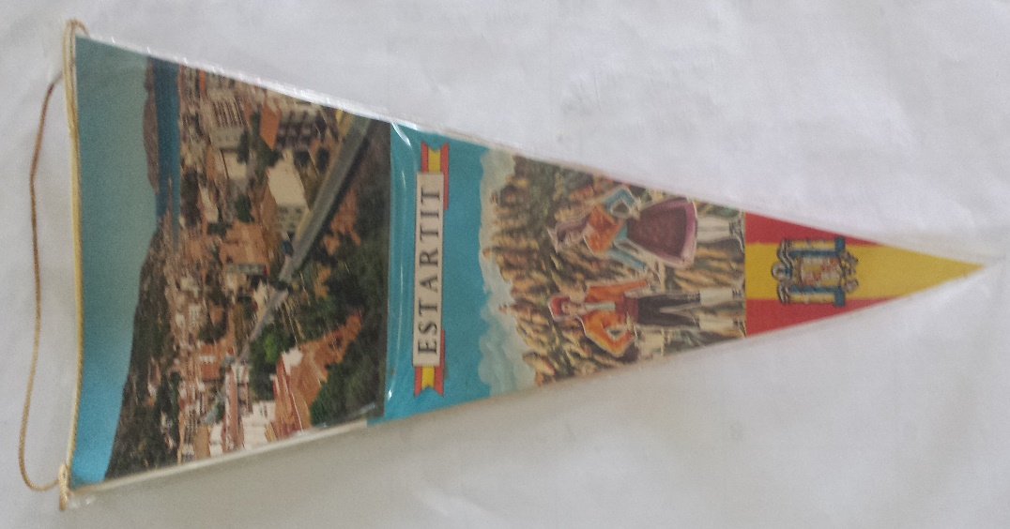
Estartit (or L’Estartit in Catalan) was a small fishing village that got caught up in the start of the Costa Brava tourist boom in the 1960s. In the 2009 census, L’Estartit had a population of 3,571. It lies north of Barcelona close to the French / Spanish border. It’s also within driving distance of Andorra. |  | 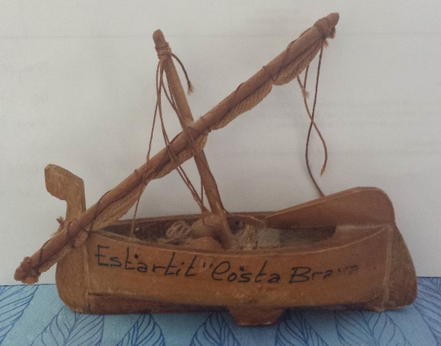
Fishing Boat from L’Estartit
(In real life it’s only 3 inches (8 centimetres) long.
A Souvenir of the times.)
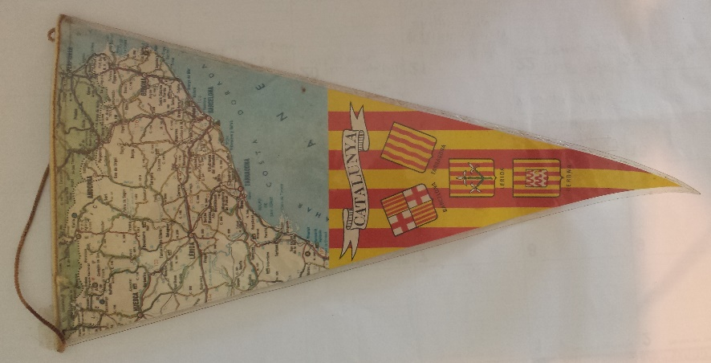 | 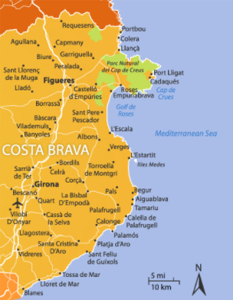  Where is L’Estartit? It’s on the coast half way between top and bottom of the map.

Memory No. 2 – Downe Camp Site
We used to go to Downe a lot. But also, Polyapes, Broadstone Warren, Chalfont Heights, Youlbury, Buckmore Park and of course Gilwell Park.
The only time I had to take a scout home midway through a camp, was from Downe.
Someone had rigged a rope from a tree in the middle of one of the numerous bomb craters.
The rope had a stick tied at the bottom so required two hands to keep it horizontal.
Someone shouted to Charlie Lawn as he swung across, to try it one handed.
The local hospital plastered his broken wrist and I took him home. Charlie’s mum was so apologetic that I had had to leave camp and as Charlie went past her, she gave him a clip round the back of his head. Nowadays who knows what the reaction would be?
Memory No. 3 – District Wide Game Scouts and Guides.
My company car at the time was a 63-seat coach which my boss had bought to transport staff from Paddington to our new building in Seven Sisters. It was on my way to work anyway so I volunteered to drive it each day as long as I could borrow it at the weekend for Scouting.
I can’t remember where this particular wide game was to be held but it was somewhere south of London fairly deep in the countryside.
On arrival, the Guide Commissioner ruled that males and females were not to share tents and the guides would be along one side of the field and the scouts along the opposite side with the leaders down the middle.*
You may recall that I had recently married the 1st Streatham Common Cub Scout Leader and we had only brought one tent with us and also none of the leaders fancied being the barrier in the middle.
The wide game involved a night navigation challenge / hike and I had to drive teams of participants and judges to various positions around the course so that not everyone started at the same point. One of the teams of judges included the Guide Commissioner who had insisted that my wife and I had to set an example and not sleep in the same tent.
I promise it was an accident, but that team of judges was dropped off over two miles from their check point.

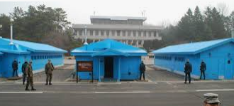
Left Side = Scouts (South Korea) Middle = Leaders Right side = Guides (North Korea)
.* The Camping model suggested by the Guide Commissioner was copied from the DMZ that is found between North Korea and South Korea.

Memory No. 4 – Caving in the Mendips and South Wales
My first “car” was the Thames Trader (323 TMX) that I used as the 3rd Streatham Scout Troop Bus. I also took Senior Scouts and Leaders on Caving weekends to Wells (Mendips) and Wales (Llangattock [Llangatwg in Welsh], near Crickhowell). Llangattock is in the Brecon Beacons National Park, in the Usk Valley and south of the village is the Llangattock Escarpment. Above these is the great gritstone plateau of Mynydd Llangatwg [Llangattock Mountain] under which can be found some of Britain’s longest cave systems, including Ogof Agen Allwedd and Ogof y Daren Cilau together with the shorter though more accessible Eglwys Faen [Stone Church] cave.

Driving up to the hut in Llangattock at night for the first time, was scary. On one trip, we went in Alan Jones’ minibus and he promptly fell into a well-earned sleep soon after we arrived. He had a camp bed and a member, (who will remain anonymous), carried him and his bed outside and left him on the side of the mountain.
When he woke, he was far from amused!
Caving weekends to the Mendips started on Friday evenings from The Railway Tavern, near Streatham Common Station, after I had finished running the Scout Troop. The M5 only went as far as Slough so it took quite a few hours to get to our destination. We used to stay in the 5th/7th Wells Scout HQ or in The Queen Victoria Inn in Priddy.

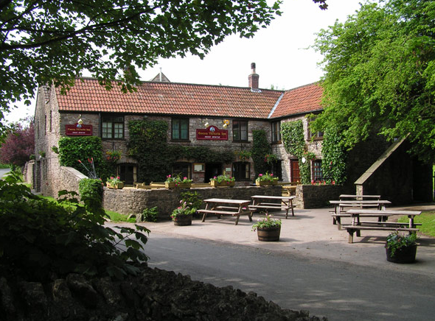
The Queen Vic, Priddy, taken 2017
Before the bunkroom was built at the Queen Vic, the girls had a small room and the boys slept in the bar with instructions to help ourselves to beer and put the money beside the till and we always did. The pub owners (the Landlord and Landlady, were Geoff and Gina) and they had an enormous dog that went by the name of Satan. He used to put its paws on your shoulders and tower above us.

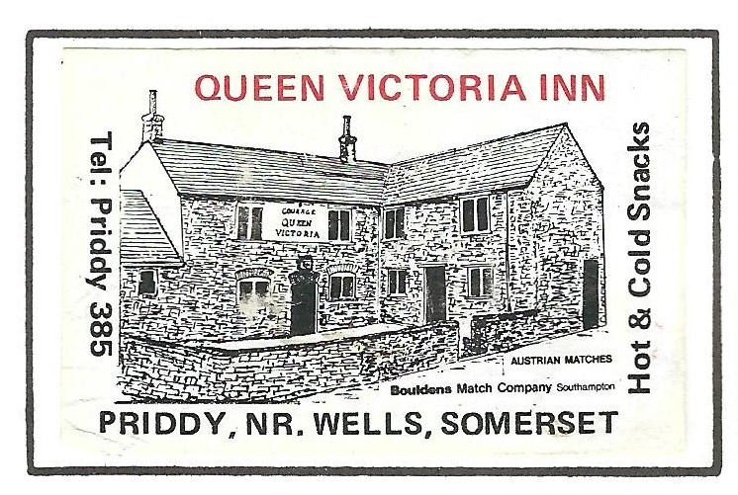
Matchbox Label from the Queen Vic, circa early 1970s

If you refer to Wayne Smith’s memories, you’ll be able to read the version in greater detail of his memories of the time that he (and others) went to the Custard Beach bar where it was all you could eat and drink for 250 pesetas. There’s not actually that much to remember, but the memory is there.
What goes on camp stays on camp! No names mentioned!
Charlie Lawn left Downe and was delivered back to his family home as Charles Lawn. If ever you called at the Lawn family home, you always had to ask for “Charles”, not Charlie.
Obviously, no sense of humour!

